**UNIVERSITY OF GHANA**

**DEPARTMENT OF COMPUTER SCIENCE**



**AN E-COMMERCE APPLICATION FOR ONLINE SHOPPING THROUGH SECURED PAYMENT METHODS**

**CASE STUDY: ACCRA SHOPPING MALL**

**A DISSERTATION SUBMITTED TO THE DEPARTMENT OF COMPUTER SCIENCE, IN PARTIAL FULFILLMENT OF THE REQUIREMENT PRESCRIBED FOR THE AWARD OF A BACHELOR OF ARTS (BA) DEGREE IN COMPUTER SCIENCE**

**BY**

**DENNIS KWABENA BILSON**

**(10527738)**

**JUNE, 2018**

**SUPERVISOR: MR. YAW TABIRI**

# **TABLE OF CONTENT**

DECLARATION………………………………………………………………………………………………………………………………………….6

DEDICATION…………………………………………………………………………………………………………………………………….………7

ACKNOWLEDGEMENTS…...………………………………………………………………………………………………………………………8

## **CHAPTER ONE**

**1.0** INTRODUCTION………………………………………………………………………………………………………………………………….6

**1.1** BACKGROUND STUDY……………………………………………………………………………………………………………………….6

**1.2** PROBLEM STATEMENT……………………………………………………………………………………………………………………… 7

**1.3** AIM OF THE PROJECT…………………………………………………………………………………………………………………………7

**1.4** OBJECTIVES OF THE STUDY……………………………………………………………………………………………………………….7

**1.5** SCOPE……………………………………………………………………………………………………………………………………………….8

**1.6** LIMITATIONS…………………………………………………………………………………………………………………………………….8

## **CHAPTER TWO**

**2.0** INTRODUCTION……………………………………………………………………………………………………………………………….9

**2.1** SURVEY OF EXISTING ONLINE SHOPPING PLATFORMS…………………………………………………………………….10

**2.2** SUCCESS AND FAILURE OF E-COMMERCE…….………………………………………………………………………………….10

**2.3** SHORTCOMINGS OF EXISTING E-COMMERCE SYSTEMS……………………………………………………………………11

**2.4** SECURING E-COMMERCE SYSTEMS….………………………………………………………………………………………………12

**2.5** LEGAL AND ETHICAL ISSUES INVOLVED IN E-COMMERCE…………………………………………………………………12

**2.6** E-COMMERCE MARKETING STRATEGIES……………………….…………………………………………………………………13

**2.7** CONCLUSION…………………………………………………………………...……………………………………………………………14

## **CHAPTER THREE**

**3.0** INTRODUCTION………………………………………………………………………………………………………………………………15

**3.1** JUSTIFICATION FOR THE EXISTING SYSTEM.……………………………………………………………………………………15

**3.2** RESEARCH METHODOLOGY….…………………………………………………………………………………………………………15

**3.2.1** QUALITITIVE RESEARCH………………………………………………….…………………….………15

**3.2.2** QUANTITATIVE RESEARCH……………………….……………………….….………………………16

**3.3** FEATURES OF QUANITITATIVE AND QUALITATIVE RESEARCH.…………………………………………………………16

**3.4** PREFERRED RESEARCH METHOD AND JUSTIFICATION….…………………………………………………………………17

**3.5** SOFTWARE DEVELOPMENT LIFE CYCLE...…………………………………………………………………………………………18

**3.5.1** SPIRAL LIFECYLCLE……………….…………………………………………………………………………………………18

**3.5.1.1** STRENGTHS …………………………………………………………………………………….19

**3.5.1.2** WEAKNESS...…………………………………………………………………………………….19

**3.5.2** RAPID APPLICATION DEVELOPMENTLIFECYLCLE…………………………………………………………....19

**3.5.2.1** STRENGTHS …………………………………………………………………………………….19

**3.5.2.2** WEAKNESS...…………………………………………………………………………………….20

**3.5.3** V-SHAPED LIFECYLCLE……………….……….…………………………………………………………………………….20

**3.5.3.1** STRENGTHS………………………………………………………………………………….…….20

**3.5.3.2** WEAKNESS...……………………………………………………………………………………….20

**3.5.4** AGILE DEVELOPMENT………….………………………………………………………………………………………….20

**3.6** PREFERRED SDLC METHOD………………………………………………………………………………………………………………20

**3.7** STRENGTHS OF PREFERRED SDLC METHOD….…………………………………………………………………………………21

**3.8** BREAKDOWNOF PROJECT STRUCTURE………………………………………………………………………………………….21

**3.9** REQUIREMENT ANALYSIS……………….…………………………………………………………………………………….……….22

**3.9.1** BACKGROUND OF THE CURRENT SYSTEM………………………………………………………….22

**3.9.2** REVIEW OF THE CURRENT SYSTEM’S BUSINESS OPERATIONS...………………………….23

**3.9.3** PROBLEM IDENITIFICATION……………………………………………………………………………….23

**3.9.4** PROJECT SPECIFICATION AND PROPOSED SYSTEM…………………………………………….24

**3.10** BENEFITS OF THE PROPOSED SYSTEM.………………………………………………………………………………………….25

**3.11** DATA FLOW DIAGRAMS…………………….………………………………………………………………………………………….25

**3.11** DATA FLOW DIAGRAMS…………………….………………………………………………………………………………………….25

**3.11.1** LEVEL -0 DFD ……………………………………………………………………………………………….…26

**3.11.1** LEVEL -1 DFD ……………………………………………………………………………………………….…27

## **CHAPTER FOUR**

**DECLARATION**

This declaration is made on the ………. day of May, 2018. I, Dennis Kwabena Bilson, with ID: 10527738 of the Computer Science Department hereby declare that the work entitled “An E-commerce application for Online Shopping Through Secured Payment Methods” is my original work. I have not copied from any other student’s work or from any other sources except where due reference or acknowledgement is made explicitly in the text, nor has any part been written for me by another person and this project has been presented as the basis for the award of a degree.

STUDENT: Dennis Kwabena Bilson

ID: 10527738

SIGNATURE: ……………………………

SUPERVISOR: Mr. Yaw Tabiri

SIGNATURE: ……………………………

**DEDICATION**

First of all, I thank the Lord Almighty for helping through this project and bringing it to a successful end. This project work dedicated to my parents, Mr. George Bilson and Mrs. Leticia Lamptey (deceased) , and also to my benefactors, Mr. and Mrs. Ishmael Oku for their invaluable support to me all this while.

**ACKNOWLEDGEMENTS**

I have taken efforts in this project. However, it would not have been possible without the kind support and help of many individuals. I would like to extend my sincere thanks to all of them.

I am highly indebted to my supervisor for his guidance and constant supervision as well as for providing necessary information regarding the project and also for his support in completing the project. I would like to express my gratitude towards my parents and siblings for their kind co-operation and encouragement which helped me in the completion of this project.

My thanks and appreciations also go to my colleagues in helping me to develop the project and people who willingly helped me out with their abilities.

**CHAPTER ONE**

**1.0 INTRODUCTION**

In recent years, information technology has greatly affected all aspects of life and to a very large extent which includes political, business and day-to-day activities. However, according to study, most people spend more time on their handheld devices which can make the purchasing of products and services a lot easier since people do not have to go to retail stores directly.

Online shopping is the process where consumers directly buy goods or receive services from a vendor interactively in real-time without an intermediary service over the internet. In the instance is a form of electronic commerce used for business-to-business (B2B) and business-to-consumer (B2C) transactions.

I present the design and implementation of an e-commerce system for online shopping through secured payment methods. This system improves upon the old system of purchasing products directly from retail outlets.

* 1. **BACKGROUND OF STUDY**

Internet shopping is still in evolutionary stage in Ghana and very few studies have undertaken research exploring customer acceptance and diffusion of internet shopping in Ghana. Although there has been a dearth of internet shopping related studies in Ghanaian context, theoretical exploration can be based on various international studies carried out in other countries. The online consumer market place is growing at an exponential rate. At the same time, technology has enhanced the capacity of online companies to collect, store, maintain, transfer and analyze vast amount of data from and about the consumer who visit their web sites. This increase in the collection and use of data has raised public awareness and consumer concern about online privacy.

Globally, one third of consumers prefer to do online shopping at retailers that have only an online presence as in the case of Tonaton, OLX and Jumia. 20% of customers prefer those sites that also have traditional stores whereas 16% of customers globally indicate that they have never shopped online. Almost half (47%) of online consumers indicate that they have never made online purchase. Shoppers considers online reviews and peer recommendations while researching future purchases of consumer electronics, cars and travel, and 40% of online shoppers would not even buy electronics without consulting online reviews first. t. 79% of online European consumers plan to purchase products or services via the Internet. Online reviews and opinions were most important when buying and researching cars, software and consumer electronics. Nielsen Report, (2014) found that almost half of global respondents in an online survey intend to purchase clothing or make airline or hotel reservations using an online device in the next six months. Other categories growing in prominence for online shopping include e-books, event tickets, sporting goods and toys (to name a few). Spending intentions for each have risen at a double-digit or near

double-digit percentage-point rates since 2011. The online market for buying groceries and other consumable products is comparatively smaller but is starting to show promise. While durables are the starting point of adoption, consumables are attractive due to the frequency of purchase. Aside from online purchasing, digital is an increasingly important research and engagement platform. Consumable categories are not likely reach the same level of online prominence as non-consumable categories due to the hands-on buying nature and perishability of the products, but the market is wide open and an eager audience is at the ready. Master Card Worldwide Insights, (2008) studied that internet penetration, income levels and cultural factors are key drivers of online shopping. In China and India, huge growth in online shopping is expected as income and internet penetration rise. Credit cards are preferred payment mode in online shopping, although some people prefer to pay through the infamous mobile money platform available to them by the network providers. The rising population of upper-middle income and increasing income level will probably boost the online shopping markets in China and Ghana. Forrester Research, (2012) found that Ghana’s eCommerce market is at an early stage but is expected to see huge growth over the next four to five years. Retailers have a sizeable opportunity as the online population starts to spend more and buy more frequently online. Two key areas that companies must focus on in all markets are localized payment and fulfilment options. Over the past 12 months, venture capitalists have invested heavily in Ghana’s eCommerce market, new players have emerged, and the eCommerce ecosystem has developed, presenting a huge opportunity for companies willing to work through some of the logistics and payments challenges in Ghana.

* 1. **PROBLEM STATEMENT**

The problem encountered in shopping directly from retailers over the past years include:

1. **Product Selection and Availability**

Limited to only products sold at the local level; customers cannot get different varieties with respect to brands, prices and more. Although depending on the store size, selection may be limited but this is not always the case especially for retail outlets as large as the Accra Shopping Mall for instance.

1. **Base price**

To compete with online purchasing, retail outlets are slashing down the prices of their products all around. Irrespective of that, online purchasing comes with product discounts, coupons and more.

1. **Taxes and Delivery**

Payment of local sales tax at a retail and charges for delivery of purchased items makes in-store purchasing a bit more expensive.

1. **Security**

There is always the rare case of identity theft at some level.

1. **Checkout points**

Checkout can also be very tedious. Long queues irate customers or even cashiers. Heavy push carts or baskets can be unappealing in physical retail stores.

1. **Reachability**

Shopping outlets that operate using the old system where people have to come to the shops in person to make their purchases do not always have reach more potential customers as compared to the popular e-commerce applications out there.

* 1. **AIM OF THE PROJECT**

The main aim of this project is to design and implement an e-commerce system for online shopping through secured payment methods using android and web technologies.

* 1. **OBJECTIVES OF THE STUDY**

The specific objectives of the proposed system are:

1. **Reach out to a larger market**

The main aim of this project is for the Accra mall shopping outlets to reach as many potential customers as possible in order to grow exponentially.

1. **Make online shopping services available to customers anytime**

The virtual shop remains open and operational 24 hours a day throughout the week and therefore reduces the work overload

1. **Make secured payments**

Allow users to checkout purchased items using secured payment platforms including the various mobile money platforms available and credit cards.

* 1. **SCOPE**

The system will only consider the Accra Shopping Mall. The android application will be used by University of Ghana’s Computer Science final year students. The system will not accept payment via credit cards and ATM cards.

* 1. **LIMITATIONS OF THE SYSTEM**

Mobile devices which support Android Operating System 5 (Lollipop = API 21) will be able to use this system. The system does not handle the shipping and delivery of the purchased items; the system only accepts purchase orders and notifies the customer of his shipping or delivery details.

**CHAPTER TWO**

**LITERATURE REVIEW**

**2.0 INTRODUCTION**

Michal Pilik, (2012) examined that online buying behavior is affected by various factors like, economic factors, demographic factors, technical factors, social factors, cultural factors, psychological factors, marketing factors and legislative factors. Customers choose an online-shop mainly based on references, clarity and menu navigation, terms of delivery, graphic design and additional services. Complicated customers read discussions on the Internet before they spend their money online and when customers are unable to find the product quickly and easily they leave the online-shop. Dibb et al., (2001), Jobber, (2001), Kotler, (2003) described Consumer buying process as learning, information-processing and decision-making activity divided in several consequent steps: Problem identification, Information search, Alternatives evaluation, Purchasing decision, Post-purchase behavior. Efthymios Constantinides, (2004) identified the main constituents of the online experience as follows: the functionality of the Web site that includes the elements dealing with the site’s usability and interactivity, the psychological elements intended for lowering the customer’s uncertainty by communicating trust and credibility of the online vendor and Web site and the content elements including the aesthetic aspects of the online presentation and the marketing mix. Usability and trust are the issues more frequently found to influence the online consumer’s behavior. Karayanni, (2003) examined that in discriminating of potential determinants between web- shoppers and non-shoppers, the most major discriminant variable between them was found to be web- shopping motives concerning time efficiency, availability of shopping on 24 hours basis and long queues avoidance.

Lack of trust to web shopping affects negatively web shopping behavior. Bosnjak et al., (2007) noticed that neuroticism, openness to experiences, and agreeableness has small, but significant influences on the willingness to buy online. Need for Cognition has a direct negative effect towards willingness to online purchase. Lack of online shopping experience could emphasize the effects of personality traits on the estimation of likelihood of future online purchases. They implied that the decision to shop online is made with emotion rather than reasoning. Lee, (2009) augmented that quality of online reviews has a positive effect on the purchasing intention of online shoppers. Attitudes of online consumers increase with the number of reviews.

Large number of reviews is perceived as an indication of product popularity and hence increases the purchasing intention of consumers. Kim et al., (2002) studied that significant factors affecting the intention towards shopping on the internet are convenient and dependable shopping, reliability of retailer, additional information and product perception. Online Shopping Customer Experience Study, (2012) stated that satisfaction of online consumers can be improved by improving their satisfaction related to shipping and returns. Free shipping is a great motivator, drawing shoppers back to sites to make repeat purchases and causing shoppers to recommend an online retailer, consumers are willing to pay a nominal fee for getting their product faster. While comparison shopping, consumers take product price and shipping charges almost equally into consideration. There are several other things that retailers can do to improve the experience for their online shoppers. The first is to communicate the expected delivery date of the order, customers are willing to wait for their orders but want to know just how long that might be.

Timely arrival of shipments or deliveries encourage shoppers to recommend an online retailer. Consumers also like having tracking updates and delivery notifications to understand when their package is arriving. Online shoppers want flexibility in their shipping, particularly the ability to give special delivery instructions or schedule a delivery time or select an alternate delivery location. Schaupp and Bélanger, (2005) added that privacy (technology factor), merchandising (product factor), and convenience (shopping factor) are three most important attributes to consumers for online satisfaction. These are followed by trust, delivery, usability, product customization, product quality, and security.

**2.1 SURVEY OF EXISTING ONLINE SHOPPING PLATFORMS**

**2.1.1 TONATON GHANA**

Tonaton Ghana is one of the largest marketplaces in this country. This platform facilitates buying and selling of new and used items alike. It also serves as a platform for searching for jobs online.

With respect to customers, Tonaton seeks to provide unrestricted services to its them. Online shopping can be accomplished without the restriction of the time and place. Due to the application of the advanced internet technology, consumers can select and purchase goods at anytime from anywhere. One instance is where Tonaton provides 24 hours services a day which can ensure that consumers achieve the process ‘choose-purchase-payment’ whenever and wherever possible. This idea solves serious problems of traditional shopping in restrictions of the shop hours and the location of business efficiently and effectively.

Tonaton Ghana has built their own search engine which can help consumers in finding the entire products and services that are on sale. Furthermore, this service helps consumers to shop around to get a good buy quickly and easily.

**2.2 SUCCESS AND FAILURE OF E-COMMERCE**

The advent of the internet has completely changed the way most business corporations operate. The e-commerce platform uses inter-networked computers to create and transform business relationships. Web and mobile applications provide business solutions that improve the quality of goods and services, reduce the cost of business operations and increase the speed of service delivery.

However, many ventures into web application development fail because of its complex nature and its continuously hanging user requirements. Inefficient communication between the developer and the end user (customers) is another contributing factor. To be successful in the development of a web application, one needs to visually model the system’s architecture. A visual model helps in coherently understanding the user requirements and effectively communicates them to the development team. Requirements analysis along with abstraction are critical factors in e-commerce development. It is easier and more cost effective to correct an error at the requirement or design stage than at the implementation or maintenance stage. Furthermore, formal specification provides unambiguous, correct and precise understanding of the user’s requirements.

**2.3 SHORTCOMINGS OF EXISTING E-COMMERCE SYSTEMS**

Some products cannot be represented in shopping applications as effectively as others. Considering the sales of books, CDs and software across the internet, the customer has a clear idea of what he is getting. Goods such as clothes and audio equipment fare less well because the customer would like to experience them (by trying them on or listening to them for instance) before making payments. For example, UK E-commerce legislature requires organizations to comply with the laws of every country they provide services to. A little legislation can go a long way towards helping parties to establish better boundaries to work within. When a transaction that takes place between two different parties located in two different countries goes wrong then a number of complex questions arise.

Problems that arise from using some of the above e-commerce systems are:

1. **Insecurity:** Customers are unable to verify whether or not the person they are making the purchase from is credible and trust worthy.
2. **Price manipulation:** This occurs when a hacker is able to change prices on the website. Internet traders sometimes must find a balance between ease-of-use for the customer, and security restrictions at the point of purchase. Payment solutions and shopping carts offer various security features, but often they prove too inflexible and the extra security is not enabled. If a customer does not manage to alter the price of an order, or mark an unpaid order as paid, it might go undetected by the website software.
3. **Data leakage vulnerability:** Database-driven websites are very common, and parameters of a database query can often be seen in the URL of web pages. When information is passed in the URL in this way, a malicious user can iterate through the sequence and extract information that is held in the website database.
4. **Background attacks:**  A hacker can change the background of e-commerce websites
5. **SQL Injection:** This isa subset of unauthorized user input vulnerability whose idea is to run SQL code that was not intended. Hackers can gain access to protected data, user’s account information, delete data in tables and more. It is a very critical vulnerability which can lead to a high level of compromise where any database query can be made without validation of the user.
6. **Weak Login Forms Vulnerability:** Most shopping carts have two login pages, one for customers and another one for merchants. Either of these secured areas may be accessed by an account with a weak login combination. An attacker can perform a brute force attack via the login form, using a proxy or a script on a shared server to mask their identity.
7. **Viruses:** A hacker can send viruses to corrupt business data.

**2.4 SECURING E-COMMERCE SYSTEMS**

With respect to the above stated possible threats to E-commerce systems, there have been recent security developments to eradicate such threats. Some of these protection measures include:

1. **Regular data backup:** Regular backup of data is an important condition of any efficient and safe information or database-driven system. In the event of an attack, files backed up and stored off-site can be re-instated, preventing the organization from losing its entire data. Data backup have to be realized so that all data have to be renewable from backup.
2. **Use of antivirus and anti-spyware software protection:** Customers should be encouraged to use antivirus and anti-spyware protection on their individual computers and servers.
3. **User training:** user training is a vital security measure as it enhances user knowledge and responsibility.
4. **Use of Encryption:** Encryption techniques should be used to protect sensitive information such as user passwords. Firebase currently offers secure server and encryption technology as a solution to the security risks associated with transmitting data through the internet. Sensitive information such as a customer’s credit card number is encoded using intended recipient’s public key before transmission, even if intercepted by a hacker it is useless without the corresponding private key.

**2.5 LEGAL AND ETHICAL ISSUES INVOLVED IN E-COMMERCE**

A recent survey reported that there are approximately 100 countries now enjoy internet access, 20 million Internet hosts worldwide and over 1.8 billion internet users. Due to the ever-increasing internet population and the anonymity of online users; certain regulatory and legal issues have to be adhered to in order to develop 27 efficient e-commerce systems. As a result, strategies must be implemented that conform to e-commerce rules and regulations. Questions arising from development of E-commerce systems include:

1. How does copyright apply to digital content?
2. How can national e-Commerce laws apply to activities in cyberspace?
3. How to ensure privacy and data protection exist on the Web?

E-commerce presents a world of opportunity for doing businesses, reaching global markets and purchasing without leaving the home or office. E-commerce can provide opportunities to improve business processes, just as phones, faxes and mobile communications have in the past. However, just as any new business tool has associated issues and risks so does e-commerce.

The issue of law on the Internet is a complex one. Between the two all-or-nothing extremes lies a broad spectrum of possibilities. Many people revel in the freedom to express themselves and the freedom from prohibitions such as zoning restrictions that the Internet apparently affords. Without law, however, the Internet would be no place to conduct business. Laws give people certainties about their rights and responsibilities: they make life more predictable. According to Thomas Vartanian, "Without predictability, business will not be able to act efficiently, or price services effectively,". Some of these issues include:

1. **Electronic transactions**

Some federal, state and territory governments encourage the adoption of electronic commerce by enacting and enabling legalization. In the UK many bills and acts have been passed to resolve legal issues and make electronic transaction more authenticated, such as The Electronic Commerce (EC Directive) Regulations 2002. The Directive was introduced to clarify and harmonize the rules of on-line business throughout Europe with the aim of boosting consumer confidence. The EC Directive enables contractual dealings, such as offers, acceptances and invitations, to be conducted electronically, also allowing people to use an electronic signature to satisfy any legal requirement. This directive has as expected boosted electronic commerce as an effective tool for businesses to increase their efficiency. This has reduced administrative duties, storage and operational costs for businesses. In McGinty's words," This is why it is crucial that we ensure the legal infrastructure around cyberspace is beyond doubt".

1. **Privacy and Security**

The Privacy and Electronic Communications Regulations 2003 apply to unsolicited electronic marketing messages sent by telephone, fax, email or text. The Privacy and Electronic Communications Regulations 2003 (‘the regulations’) give rules that govern electronic marketing. This legislature sets the standards for email marketing. The e-commerce system should make provisions for subscribers to opt out of direct marketing emails. Individual and corporate subscribers can register their objection to receiving unsolicited direct marketing faxes by registering their number with the Fax Preference Service. Unsolicited marketing material by electronic mail (this includes texts, picture messages and emails) should only be sent if the person has chosen to receive them, unless the email address was obtained as a result of a commercial relationship. The individual should always be given the opportunity to stop receiving the emails. The e-commerce system must also ensure the safety and security of a customer's personal information. The e-commerce system should provide the customers with information regarding the use of their personal information, and incorporate security procedures to limit access to customer information by unauthorized parties. Privacy policies and procedures should be clearly explained to customers. Customer data must be collected, stored and manipulated in compliance with the Data Protection Act 1998.

1. **Copyright and Trademark**

A trademark can be owned by an individual, a company, or any sort of legal entity. When someone else tries to use that trademark (e.g., your distinctive name or logo) without authorization, it could be considered an illegal dilution of the distinctive trademark. If someone uses a trademark in such a way as to dilute the distinctive quality of the mark or trade on the owner's reputation, the trademark owner may seek damages. A number of important recent developments have occurred in the field of copyright and related issues that have far-reaching implications for the industry, and are being addressed in legislatures, judiciaries and international forums. During the last couple of years, new laws have passed in some countries to ensure effective protection and enforcement of rights in the digital era. Such example is the UK copyright law which was amended in November, 2009 to include web and digital content.

**2.6 E-COMMERCE MARKETING STRATEGIES**

The following marketing strategies would enable the proposed system to experience growth by delivering effective and compelling business-to-consumer marketing campaigns that correct, motivate and drive consumers act.

1. **Branding**

Giving the proposed system a unique identity among all the competition in the market is tough. This is where branding can help. Branding involves personifying the business by leveraging on brand awareness to build stronger relationships with customers. Ideally, the brand should influence every aspect of the business operation because the successful brands of today will be those capable of producing customer-centric business models consistently.

1. **Internet marketing**

Helps in developing a direct contact between the consumer and shopping outlets and also allows the business to advertise and sell their products and services in an easy way. The business-to-consumer campaigns employ strategies and tactics such as targeted offers and coupons; limited time deals, discounts, and / or vouchers to mobilize target markets to buy, both online and offline. The system would recognize the importance of customer loyalty and combine merchandising and education to keep customers coming back using newsletters.

**2.7 CONCLUSION**

E-commerce has become a significant element in the modern global economic environment. It represents the use of a computer network, primarily the Internet, to buy and sell products, services, information, and communication. E-commerce is also an application of technology using the Internet. In addition, it is a tool for increasing efficiency and lowering costs in organizations.

Having reviewed the existing of e-commerce systems, their architecture, advantages, disadvantages, legal and ethical issues, the next section of this report investigates the research methods to be used in requirements gathering for the development of the proposed system.

**CHAPTER THREE**

**SYSTEM ANALYSIS**

**3.0 INTRODUCTION**

System analysis is the study of an existing system, the purpose of which is to determine if there are any problems or shortcomings of the system (Stair,1986).

* 1. **JUSTIFICATION FOR THE EXISTING SYSTEM**

A series of interviews were carried out with the head staffs in the various shopping outlets of the Accra Shopping Mall on May 18, 2018. The interview conducted covered the procedures for the ordering and delivery of products to online customers. It was said because the mall itself does not have a full e-commerce system for its shopping outlets, most customers place orders through mobile phone calls and email. Although some of the shopping outlets like Jet and Edgars had a dedicated website for this business, most of the other outlets rely solely on their customers who physically visit the mall. The head of one of the shopping outlet which dealt in mobile phone sales said that their products (the mobile phones) can be sold over the internet but “some customers preferred to have a feel of the product before making their purchase”. Irrespective of this solid point made, not all potential customers will be covered through this approach. There was no dedicated delivery system used in the mall as at the time this interview was taken and therefore customers who make orders over the phone had to come to the shopping outlet to pick up their products.

**3.2 RESEARCH METHODOLOGY**

A research methodology is needed for requirements gathering on the proposed system. In order to fully understand the end-user requirements, which will be the basis of the system design and implementation; a suitable research methodology and system analysis method must be employed. This section of the report will critically evaluate the current research methods in use and select the best method most suited for this project.

* + 1. **QUALITATIVE RESEARCH**

Qualitative research explores attitudes, behavior and experiences through such methods as interviews or focus groups. It attempts to get an in-depth opinion from participants. As it is attitudes, behavior and experiences which are important, fewer people take part in the research, but the contact with these people tends to last a lot longer. Under the umbrella of qualitative research there are many different methodologies.

As compared to quantitative research, there is no overarching framework for how qualitative research should be conducted; rather each type of qualitative research is guided by particular philosophical stances that are taken in relation by the research to each phenomenon (O'Brien, n. d.).

Qualitative research is a type of scientific research. In general terms, scientific research consists of an investigation that:

1. Seeks to answer a question
2. Systematically uses a predefined set of procedures to answer the question
3. Collects evidence
4. Produces findings that are applicable beyond the immediate boundaries of the study

Qualitative research shares these characteristics. Additionally, it seeks to understand a given research problem or topic from the perspectives of the local population it involves. Qualitative research is especially effective in obtaining culturally specific information about the values, opinions, behaviors, and social contexts of particular populations.

There are three main types of data collection namely:

1. **Interactive interviewing:** People asked to verbally describe their experiences of phenomenon.
2. **Written descriptions by participants:** People asked to write descriptions of their experiences of phenomenon.
3. **Observation:** Descriptive observation of verbal and non-verbal behavior.

Analysis begins when the data is first collected and is used to guide decisions related to further data collection.

* + 1. **QUANTITATIVE RESEARCH**

This type of research typically includes customer surveys and questionnaires. These can be conducted face-to-face with a clipboard and pen, over the telephone, via post or email, online. Survey questions are usually carefully considered so that the results will provide meaningful data (which is not usually the case).

* 1. **FEATURES OF QUANTITATIVE AND QUALITATIVE RESEARCH**

James Neil, discussed the features and comparisons of both methods of research as shown below:

|  |  |
| --- | --- |
| Qualitative Research | Quantitative research |
| The aim is a complete, detailed description | The aim is to classify features, count them, and construct statistical models in an attempt to explain what is observed |
| Researcher may only know roughly in advance what he/she is looking for. | Researcher knows clearly in advance what he/she is looking for. |
| Recommended during earlier phases of research projects. | Recommended during latter phases of research projects |
| The design emerges as the study unfolds. | All aspects of the study are carefully designed before data is collected |
| Researcher is the data gathering instrument. | Researcher uses tools, such as questionnaires or equipment to collect numerical data. |
| Data is in the form of words, pictures or objects. | Data is in the form of numbers and statistics. |
| Subjective - individuals’ interpretation of events is important, e.g., uses participant observation, in-depth interviews etc. | Objective – seeks precise measurement & analysis of target concepts, e.g., uses surveys, questionnaires etc. |
| Qualitative data is ‘richer’, time consuming, and less able to be generalized. | Quantitative data is more efficient, able to test hypotheses, but may miss contextual detail. |
| Researcher tends to become subjectively immersed in the subject matter. | Researcher tends to remain objectively separated from the subject matter. |

Critical science, or the critical approach, explores the social world, critiques it, and seeks to empower the individual to overcome problems in the social world. Critical science enables people to understand how society functions and methods by which unsatisfactory aspects can be changed.

* 1. **PREFERRED RESEARCH METHOD AND JUSTIFICATION**

The preferred research methodology for the proposed system is the qualitative method. This is because it is the most complete research methodology for the proposed system, as the requirement specification needs to be generated from qualitative data; a view ascertained by Donald Campbell “All research ultimately has a qualitative grounding" and Fred Kerlinger "There's no such thing as qualitative data. Everything is either 1 or 0".

Qualitative methods are typically more flexible; allowing greater spontaneity and adaptation of the interaction between the researcher and the study participant. For example, qualitative methods ask mostly “open-ended” questions that are not necessarily worded in exactly the same way with each participant. With open-ended questions, participants are free to respond in their own words; with the proposed system, these questions will be well structured with responses simply “yes” or “no.”. Such method of using questions with abstract answers will eliminate ambiguous responses, which may have led to poor system requirement specification. In addition, with qualitative methods, the relationship between the researcher and the participant is often less formal than in quantitative research. Participants have the opportunity to respond more elaborately and in greater detail than is typically the case with quantitative methods. In turn, researchers have the opportunity to respond immediately to what participants say by tailoring subsequent questions to information the participant has provided.

Qualitative research methods generate statistics from target audience, usually a small number of system end-users. This method is more suited to the proposed system as it will target the customers and staff of the Accra Mall shopping outlets as opposed to collecting random information for system requirements analysis from users of other E-commerce systems. Quantitative research not suited for this project as it generates statistics through the use of large-scale survey research, using methods such as questionnaires or structured interviews. This could include stopping individuals on the streets or sending questionnaires by post. Though this type of research reaches many more people, the results will be a set of conflicting and/or redundant data.

The methods that will be employed in the requirements gathering for the system include:

1. **Participant observation:** It isappropriatefor collecting data on naturally occurring behaviors in their usual contexts.
2. **Daily business operations** and data structures will be observed.
3. **In-depth interviews** are optimal for collecting data on individuals’ personal histories, perspectives. These interviews will be conducted with the owner, staffs and selected customers of the proposed system, which in this case is the final year computer science students of this university. The strength of qualitative research is its ability to provide complex textual descriptions from interviews and questionnaire of how people experience a given research issue. It provides information about the “human” side of an issue – that is, the often-contradictory behaviors, beliefs, opinions, emotions, and relationships of individuals. Qualitative methods are also effective in identifying intangible factors, such as social norms, socioeconomic status, gender roles, ethnicity, and religion.
   1. **SOFTWARE DEVELOPMENT LIFE CYCLE (SDLC)**

The Systems Development Life Cycle (SDLC) is a systematic approach for application development or system development. SDLC is the process of building the system that result in a high quality, cost-effective, within time and efficient application that is cheap to maintain, easy to enhance and that can work effectively.

It is divided in several phases and each phase comprised of multiple steps, and they are as follows: It is a conceptual model used in project management that describes the stages involved in an information system development project from an initial feasibility study through maintenance of the completed application. Various SDLC methodologies have been developed to guide the processes involved including the waterfall model (the original SDLC method), rapid application development (RAD), joint application development (JAD), the fountain model and the spiral model.

* + 1. **SPIRAL LIFECYCLE**

The spiral model starts with an initial pass through a standard waterfall lifecycle, using a subset of the total requirements to develop a robust prototype. After an evaluation period, the cycle is initiated again, adding new functionality and releasing the next prototype. This process continues, with the prototype becoming larger and larger with each iteration.

The theory is that the set of requirements is hierarchical in nature, with additional functionality building on the first efforts. This is a sound practice for systems where the entire problem is well defined from the start, such as modeling and simulating software. Business-oriented database projects do not enjoy this advantage. Most of the functions in a database solution are essentially independent of one another, although they may make use of common data. As a result, the prototype suffers from the same flaws as the prototyping lifecycle described below. For this reason, the spiral lifecycle is not considered for this database project.

* + - 1. **STRENGTHS OF THE SPIRAL MODEL**

Provides early indication of insurmountable risks, without much cost. Users see the system early because of rapid prototyping tools, critical high-risk functions are developed first. The design does not have to be perfect, users can be closely tied to all lifecycle steps early and frequent feedback from users. cumulative costs assessed frequently.

* + - 1. **WEAKNESSES OF THE SPIRAL MODEL**

Time spent for evaluating risks too large for small or low-risk Projects. Time spent planning, resetting objectives, doing risk analysis and prototyping may be excessive. The model is complex, risk assessment expertise is required, spiral may continue indefinitely. Developers must be reassigned during non-development phase activities. May be hard to define objective, verifiable milestones that indicate readiness to proceed through the next iteration.

* + 1. **RAPID APPLICATION DEVELOPMENT (RAD) / PROTOTYPING LIFECYCLE**

The theory is that end users can produce better feedback when examining a live system, as opposed to working strictly with documentation. RAD-based development cycles have resulted in a lower level of rejection when the application is placed into production, but this success most often comes at the expense of a dramatic overruns in project costs and schedule. The RAD approach was made possible with significant advances in software development environments to allow rapid generation and change of screens and other user interface features. The end user is allowed to work with the screens online, as if in a production environment. This leaves little to the imagination, and a significant number of errors are caught using this process. For this reason, a pure RAD approach will not be used on this project, but instead a blend limited prototyping will me mixed with requirements and design development during a conventional waterfall lifecycle.

* + - 1. **STRENGTHS OF RAD LIFECYCLE**

Reduced cycle time and improved productivity with fewer people means lower costs. Time-box approach mitigates cost and schedule risk. Customer involved throughout the complete cycle minimizes risk of not achieving customer satisfaction and business needs. Focus moves from documentation to code (WYSIWYG). Uses modelling concepts to capture information about business, data, and processes.

* + - 1. **WEAKNESSES OF RAD LIFECYCLE**

Accelerated development process must give quick responses to the user. Risk of never achieving closure, hard to use with legacy systems. Requires a system that can be modularized, developers and customers must be committed to rapid-fire activities in an abbreviated time frame.

* + 1. **V-SHAPED SDLC**

A variant of the Waterfall that emphasizes the verification and validation of the product. Testing of the product is planned in parallel with a corresponding phase of development.

* + - 1. **STRENGTHS OF V-SHAPED MODEL**

Emphasize planning for verification and validation of the product in early stages of product development. Each deliverable must be testable, project management can track progress by milestones. It is very easy to use.

* + - 1. **WEAKNESSES OF V-SHAPED MODEL**

Does not easily handle concurrent events, does not handle iterations or phases, does not easily handle dynamic changes in requirements, does not contain risk analysis activities.

* + 1. **AGILE DEVELOPMENT**

Agile software development uses iterative development as a basis but advocates a lighter and more people-centric viewpoint than traditional approaches (Wikipedia, 2018). This methodology takes advantage of its iterative and continuous feedback that it provides to successfully refine and deliver a software system.

* 1. **PREFERRED SDLC METHOD**

The preferred SDLC for this project would be the Agile Software Development; which is described as both iterative and incremental and hence allows more important subsystems to be developed in reference to the objective of the study.

* 1. **STRENGTHS OF PREFERRED SDLC METHOD**

These are some of the reasons for my choice of SDLC for this project:

1. Easy to understand
2. Provides structure to inexperienced staff
3. Milestones are well understood
4. Sets requirements stability
5. Good for management control with respect to planning
6. Works well when quality is more important than cost
   1. **BREAKDOWN OF PROJECT STRUCTURE**

The reason for the selection of the Waterfall Model is justified in this section.

1. **Feasibility**

A feasibility study will be carried out to determine if the project can be undertaken and delivered. This study also evaluates the methods of implementation to ensure there are adequate resources to develop the proposed system. This study determines if the project gets the go-ahead from the stakeholders. If the project is to proceed, the feasibility study will produce a project plan for the future stages of development.

1. **Requirement Analysis and Design**

The goal of systems analysis is to gather relevant information on the proposed system, users, products and services and determine the problem(s) with the current operational methods and attempt to fix the highlighted problems. This step involves breaking down what needs to be created and attempting to engage users so that definite requirements can be defined.

Analysis gathers the requirements for the system. This stage includes a detailed study of the business needs of the organization. Options for changing the business process may be considered. Design focuses on high-level design (what programs are needed and how they are going to interact), low-level design (how the individual programs are going to work), interface design (what are the interfaces going to look like) and data design (what data will be required). During these phases, the software’s overall structure is defined. Analysis and Design are very crucial in the whole development cycle. Much care is taken during this phase. The logical system of the product is developed in this phase.

In the design section of the proposed system, operations are described in detail including screen layouts, process diagrams (UML activity diagrams, UML class diagram, Data Flow Diagram, Entity Relational Diagram) and other documentation.

The design stage takes as its initial input the requirements identified in the approved requirements document. For each requirement, a set of one or more design elements will be produced as a result of interviews, workshops, and/or prototype efforts.

1. **Implementation**

In this phase, the designs are translated into code. The system will be developed according to the pre-determined functions and designs. The database will be developed and the website created using different high-level programming languages like JavaScript, Java and Kotlin.

1. **Testing**

In this phase, the system will be tested and results evaluated. This stage of the development life cycle will run almost concurrently with the system implementation. Components of the system (database and website URLs) will be tested as they are created. At the end of the project, the overall proposed system will be tested to ensure that interfaces between modules work (integration testing), the system works on the intended platforms and with expected volume of data (volume testing) and that the system does what the user requires (acceptance/beta testing).

1. **Maintenance**

Inevitably, the system will need maintenance. Software will definitely undergo change once it is delivered to the customers. There are many reasons for the change. Change could happen because of some unexpected input values into the system. A good E-commerce system should be able to accommodate changes that could happen during the post implementation period. The possible further development options will be discussed in the Evaluation section of this report.

* 1. **REQUIREMENT ANALYSIS**
     1. **BACKGROUND OF THE CURRENT SYSTEM**

**(ACCRA SHOPPING MALL)**

The Accra Shopping Mall is a state-of-the-art retail and shopping center in Accra, Ghana located on the Tetteh Quarshie Interchange adjacent to the Tema Motorway. The mall was commissioned on July 4, 2008. It is one of the most modern shopping malls in West Africa and the first large-scale shopping center in Ghana.

The mall is an enclosed, fully air-conditioned shopping center. It has 20,322 square meters of retail space with parking for over 900 cars. The Accra Mall accommodate 65 line-shops and 9 restaurants of which 30% are operated by Ghanaian retailers.

This local company now operates on a Business-to-Business (B2B) and Business-to-Customer (B2C) basis where other businesses can make wholesale purchases and private customers can place individual orders.

* + 1. **REVIEW OF THE CURRENT SYSTEM’S BUSINESS OPERATIONS**

Accra Shopping Mall operate in an agile market where customers’ orders vary and it is understood that no one order is ever the same, this implies that their customers require a high level of customization and flexibility. In order keep up with customer requests, Accra Mall has to react with speed and agility to customer order demands.

After several formal interviews with relevant personnel (both key users and administrative staff), it was observed that this company operates on a computerized file system although there are some instances where records of transactions with suppliers, product information, customer and order details are manually stored, making retrieval of information very difficult. Poor computer skills among staff, opposition to change, convenience of customer service from remote sources and disinclination to learn new procedures were cited as the main reasons why the management has been reluctant to change or upgrade the current system. Current staff have basic understanding of the internet and some Microsoft office packages (for instance MS Word).

Accra Mall has several suppliers in Africa, Europe and America who provide the resources needed for their merchandise. Orders are places on monthly basis although the frequency of order changes depending on customer demand. Product information including date of manufacture, use by date, quantity of stock and the like are not made readily available on their existing website. Therefore, customers would have to go to the shopping outlets to get their products.

Orders are taken from customers over the phone or in store. Orders made in-store are picked up by customers, sometimes instantly if the orders can be met. Telephone orders are becoming more popular with customers who order in bulk as transportation of large quantities of large quantities of products purchase in-store can be inconvenient since most products are fragile. When telephone orders are received an employee refers to the product folder for information on the ordered product. If the ordered product is in stock and the order can be met then the customer is contacted and a delivery data is agreed upon. The order details which include delivery address, customer name, product details, delivery data and more are then entered and stored in a database. But unfortunately, not all the shopping outlets in the mall operate using this method; some still manually store data in folders. Payment is taken by the deliveryman on delivery and an invoice and/or receipt issued.

Once an individual or business places and order, they are given the option of being registered as a customer where their details such as customer name, address and phone number are retrieved and stored in a customer database or folder. Registered customers who regularly place orders are offered discounts and several incentives on sometimes monthly basis.

* + 1. **PROBLEM IDENTIFICATION**

The incessant growth of Accra Shopping Mall has brought on many problems particularly since they operate on a computerized file-based system alongside some manual file-based system as well. The workloads on the employees have increased tremendously in the last year; customers are usually left in orders due to delays in order processing and payment arrangements. Sometimes, orders have to be declined as the outlets cannot guarantee that they can meet these orders, with administrative duties taking most of staff time. The manual data entry method has in the past resulted in drastic loss in revenue from product sale. In some errors arising from manual data entry have led to delays and cancellation of orders as some of the outlets could not either retrieve the customer and/or order information. In other cases, orders have had to be declined as the shopping outlet cannot guarantee they can meet these orders; due to the quantity of orders to be processed, shortage of staff and the cost of hiring more staff.

Accra Mall cannot carry out credit and debit card transactions as this requires a merchant account with a bank; therefore, all orders made on the phone are paid on delivery. Not only does this create a geographic restriction on trade as they can only accept orders for delivery in Accra, it also leads to losses of income/revenue as targeting a wider geographical area will lead to more customers therefore more income; this being a benefit of an e-commerce system.

* + 1. **PROJECT SPECIFICATION AND PROPOSED SYSTEM**

With respect to the problems faced by Accra Mall, the aim of this project is to assist them in reviewing their current business methods, designing and developing an e-commerce system that will automate several processes and provide around-the-clock availability of products and services to customers; enabling customers to place orders online, providing efficient communication channels as well as marketing and advertising techniques. This system will include a database component that will store detailed information of products, customers and orders and also offer more flexible and easier methods of payment. This information will be used by the staff on the web portal to manage those orders and track customers’ location in order to make prompt deliveries. The system will have a knowledge base maintained and updated by an expert in the form of a retail administrator. From the knowledge base, product details and other relevant details will be made available to all customers.

The system will also make available to the sales and delivery team, all purchase and delivery locations through the web portal. The information will be stored in **Google’s Cloud Firestore** while the expect web portal will be developed using the combination of **JavaScript, Html** and **CSS.** The customer portal will be developed using **Kotlin, Java** and **XML.**

The system will send information through push notifications from the web portal to the customer’s handset.

The minimum requirements and functionalities required by the target device include:

1. **Android platform (Client side)**
2. Android API Level 21 (Lollipop devices and above)
3. 512 MB Device memory (RAM) or higher
4. Google Play services 12.0.1 or newer
5. Support for GPS (Global Positioning System)
6. Chrome Web browser with support for HTML5
7. **Web platform (Administrator side)**
8. Operating System (Linux, Windows, MacOS etc)
9. 1024 MB RAM or higher
10. Chrome Web Browser or any browser with support for HTML5
    1. **BENEFITS OF THE PROPOSED SYSTEM**
11. **DIRECT BENEFITS**
12. Increased cash flow as a result of the new system
13. Reduction in personnel salary bills
14. A minimum 20% increase in overall profitability and revenue as a result of more efficient system and more customers.
15. **INDIRECT BENEFITS**
16. Increased accuracy of customer and order information
17. Reduction in costs from errors
18. User friendliness and ease of use due to 24 hours availability of the system
19. **INTANGIBLE BENEFITS**

Good company image as a result of the system means more customers therefore more sales

* 1. **FUNCTIONAL REQUIREMENTS**

The functional requirements are driven by business requirements specified by Accra Shopping Mall; functional requirements describe what the website needs to do, and not how it does it. The fundamental functional requirements of the system are elaborated below:

1. The website should manage and authenticate shopping outlets in the mall

Shopping outlets in the mall should be able to register an account with the system in a more secured.

1. The website should authenticate and manage the staff personnel for each shopping outlet

Staff personnel of each registered shopping outlet should be able to register and account or login to an existing one using their email addresses and encrypted passwords.

1. The website should serve as an inventory management system for the registered shopping outlets

The stock or products and services provided by the various shopping outlets registered onto the system should be managed directly from the website in a professional manner meeting all standards of online product and data management procedures. Products should be added, updated and deleted directly from the website.

1. The website should manage customers’ orders in real-time
2. The android application should allow customers to review products

Customers should be allowed to review products uploaded onto the system through comments and ratings in real-time through the android application platform.

1. The android application should allow customers to purchase products through their preferred payment platforms

Customers should be allowed the option to choose between paying for their ordered products using payment platforms such as their mobile money accounts, credit card or debit cards respectively.

1. The android application should allow restricted access to unauthenticated users

Customers who are not registered or logged in to the system should be constrained to use certain features of the application such as browsing through some category of products and making reviews on them to some extent.

1. The android application should track delivery of goods in real-time

Products ordered using the system should be trackable by the customer in real-time in order for them to know the time and distance covered by the products and the reason for the delivery cost incurred on them.

* 1. **NON-FUNCTIONAL REQUIREMENTS**

1. **AVAILABILITY:** The system shall be available to users on the internet. And should be available to administrators at all times.
2. **ROBUSTNESS:** The system should be able to recover from any event that may cayuse disruption.
3. **RELIABLE:** The system should be able to function under all conditions, no matter the situation. There is room for hardware, software and network failures.
   1. **DATA FLOW DIAGRAMS**

Data Flow Diagram (DFD) is used to show the relationship among the business processes within an organization to external systems, external organizations, customers and other business processes.

DFDs define how information is processed and stored and identify how the information flows through the processes. The system’s data flow diagram will enable understanding of:

1. The data processes involved in the system, where these processes pass through, where they come from and where they go.
2. The inputs: what happens to the data once it enters the system?
3. The outputs: what happens before data leaves the system?
4. Any delays occurring between the inputs and outputs (i.e. identifying the need for data stores).

The following symbols are generally used with DFDs:

1. Data flow is represented by a labelled arrow
2. Processes are represented by labelled circles
3. Information sources and sinks are represented by boxes
4. Files are represented by a double line
5. Process represents a task in the system that processes data or performs some action based on the data.
6. Data Store represents a repository where data is saved or retrieved, but not changed. Examples of data store include a database.
7. External Interactor represents an entity that exists outside the system being modelled and which interacts with the system at an entry point: it is either the source or destination of data. In this case, a human using the system is the external entity.

**3.11.1 LEVEL 0 DFD (FOR “THE PHOENIX” E-COMMERCE ONLINE ORDERING SYSTEM)**

**3.11.2 LEVEL 1 DFD (FOR “THE PHOENIX” E-COMMERCE ONLINE ORDERING SYSTEM)**

**CHAPTER FOUR**

**SYSTEM DESIGN**

* 1. **INTRODUCTION**

System design is the process of defining the architecture, components, modules, interfaces and data for a system to satisfy specified requirements.

* 1. **DATABASE DESIGN MODELS**

In this section of the report, we examine, review and select a database design method for the development of “The Phoenix” E-commerce system.

* + 1. **OBJECT-ORIENTED DATABASES**

Object-oriented databases employ a data model that supports object-oriented features and abstract data types. OO databases provide unique object identifiers (OIDs) so that the objects can be easily identified. This is similar to a primary key in the relational model. Object-oriented databases utilize the power of object-oriented programming languages to provide excellent database programming capability. The data in object-oriented database management systems (OODBMSs) is managed through two sets of relations, one describing the interrelations of data items and another describing the abstract relationships (inheritance). These systems employ both relation types to couple data items with procedural methods (encapsulation). As a result, a direct relationship is established between the application data model and the database data model. The strong connection between application and database results in less code, more natural data structures, and better maintainability and reusability of code. OO languages, such as C++ or Java, are able to reduce code size by not having to translate code into a database sublanguage such as SQL and ODBC or JDBC.

* + - 1. **THE NEED FOR OBJECT-ORIENTED DATABASES**

The increased emphasis on process integration is a driving force for the adoption of object-oriented database systems. For example, the Computer Integrated Manufacturing (CIM) area is focusing heavily on using object-oriented database technology as the process integration framework. Advanced office automation systems use object-oriented database systems to handle hypermedia data. Hospital patient care tracking systems use object-oriented database technologies for ease of use. All of these applications are characterized by having to manage complex, highly interrelated information, which is the strength of object-oriented database systems. Clearly, relational database technology has failed to handle the needs of complex information systems. The problem with relational database systems is that they require the application developer to force an information model into tables where relationships between entities are defined by values.

* + - 1. **FEATURES OF OODB**

Object-Oriented DBMS (OODBMS) are DBMS which are based on an Object-Oriented Data Model. Such data models are often inspired by OO programming languages, such as Smalltalk or C++. OODBMS are capable of storing complex objects, I.e., objects that are composed of other objects, and/or multi-valued attributes. The great advantage of OODBMS is that it is not necessary to transform the UML classes into a logical schema (e.g., relational). Their main disadvantage is that the technology is immature and they are only used in niche applications, such as CAD. Greater support for complex objects; No query language is required you just retrieve individual objects like some giant key/value store. No relational referential integrity: though you may have one object contain a reference to another object.

* + - 1. **DRAWBACKS OF OODB**

A key difference between relational databases and OO databases is the way in which relationships are handled. In OO databases, the relationships are represented explicitly with OIDs, which improves the data access performance. In relational databases, relationships among tuples are specified by attributes having the same domain. The main drawback of OODBMSs has been poor performance. Unlike RDBMSs, query optimization for OODBMs is highly complex. OODBMSs also suffer from problems of scalability and are unable to support large-scale systems.

* + 1. **RELATIONAL DBMS (RDBMS)**

The relational model was formally introduced by Dr. E. F. Codd in 1970 and has evolved since then, through a series of writings and later through implementations by IBM and others. A relational database is composed of many relations in the form of two-dimensional tables of rows and columns containing related tuples. Organizing data into tables, the form in which data is presented to the user and the programmer, is known as the logical view of the database. The stored data on a computer disk system is called the internal view. The rows (tuples) are called records and the columns (fields in the record) are called attributes. Each column has a data type (i.e., int, float, date). There are various restrictions on the data that can be stored in a relational database. These are called constraints. The constraints are domain constraints, key constraints, entity integrity constraints, and referential integrity constraints. These constraints ensure that there are no ambiguous tuples in the database. RDBMSs use Structured Query Language (SQL, currently SQL2) as the data definition language (DDL) and the data manipulation language (DML). SQL includes statements for data definition, modification, querying and constraint specification. The types of queries vary from simple single-table queries to complicated multi-table queries involving joins, nesting, set union/differences, and others. All processing is based on values in fields of records. The main disadvantages of Relational Databases include their inability to handle application areas like spatial databases objects e.g. database applications involving images, or special types databases (e.g. involving complex numbers, arrays, etc.) and other applications that involve complex interrelationships of data. The SQL standard enables users to easily migrate their database applications between database systems. In addition, users can access data stored in two or more RDBMSs without changing the database sub-language (SQL). The other merits include rapid data access and large storage capacity.

* + 1. **OBJECT-RELATIONAL DBMS (ORDBMS)**

The main objective of ORDBMS design was to achieve the benefits of both the relational and the object models such as scalability and support for rich data types. ORDBMSs employ a data model that attempts to incorporate OO features into RDBMS. All database information is stored in tables, but some of the tabular entries may have richer data structure, termed abstract data types (ADTs). The ORDBMS has the relational model in it because the data is stored in the form of tables having rows and columns and SQL is used as the query language and the result of a query is also table or tuples (rows). The characteristics of ORDBMSs include;

1. Base datatype extension,
2. Support complex objects,
3. Inheritance, and
4. Rule Systems

ORDBMSs allow users to define data types, functions and operators. As a result, the functionality of the ORDBMSs increases along with their performance. An example schema of a product relation which ORDBMS supports is: Product (id, name, description, address, picture) The extra attribute "picture" is not present in the traditional EMPLOYEE type of relation of RDBMS. The datatype of "picture" is "image". Object-relational extensions to relational DBMS’s capture much of the advantages of OODB yet retain the relation as the fundamental abstraction. Object-Relational data modeling supports some object-oriented concepts, while still supporting some relational concepts:

1. Inheritance: one table can have an IS-A relationship with another table. Likewise, custom data types support inheritance.
2. Distinction between a class and an object (instance of a class) that goes beyond simply the distinction between a table and a row.
3. Custom or complex data types.
4. Relational query language.
5. Referential integrity.
   * 1. **NO-SQL DATABASES**

Relational databases were not designed to cope with the scale and agility challenges that face modern applications, nor were they built to take advantage of the commodity storage and processing power available today through NoSQL databases.

1. **Document databases** pair each key with a complex data structure known as a document. Documents can contain many different key-value pairs, or key-array pairs, or even nested documents.
2. **Graph stores** are used to store information about networks of data, such as social connections. Graph stores include Neo4J and Giraph.
3. **Key-value stores** are the simplest NoSQL databases. Every single item in the database is stored as an attribute name (or key), together with its value. Some key-value stores such as Redis allow each value to have a type such as ‘integer’, which adds functionality.
4. **Wide-column stores** such as Cassandra and HBase are optimized for queries over large datasets, and store columns of data together, instead of rows.

**4.3.5 THE DIFFERENCES BEWTEEN THE THREE DATABASE DESIGN APPROACHES**

|  |  |  |  |  |
| --- | --- | --- | --- | --- |
| **CRITERIA** | **RDBMS** | **ODBMS** | **ORDBMS** | **NO-SQL** |
| Defining standard | SQL2 | ODMG-2.0 | SQL3 (in process) | Non-relational or non-SQL |
| Support for object-oriented features | Does not support; It is difficult to map program object to the database | Supports extensively | Limited support; mostly to new data types | Supports extensively |
| Usage | Easy to use | OK for programmers; some SQL access for end users | Easy to use except for some extensions | Easy to use |
| Support for complex relationships | Does not support abstract datatypes | Supports a wide variety of datatypes and data with complex interrelationships | Supports Abstract datatypes and complex relationships | Supports extensively |
| Performance | Very good performance | Relatively less performance | Expected to perform very well | Very good performance |
| Product maturity | Relatively old and so very mature | This concept is few years old and so relatively mature | Still in development stage so immature. | Relatively matured |
| The use of SQL | Extensive support for SQL | OQL is similar to SQL, but with additional features like Complex objects and object-oriented features. | SQL3 is being developed with OO features incorporated in it | Supports SQL |
| Advantages | Its dependence on SQL, relatively simple query optimization hence good performance | It can handle all types of complex applications, reusability of code, less coding | Ability to query complex applications and ability to handle large and complex applications | Ability to scale and perform well over complex data types and models |
| Disadvantages | Inability to handle complex applications | Low performance due to complex query optimization, inability to support large-scale systems | Low performance in web applications | May compromise consistency of data stored in favor of speed |
| Support from vendors | It is considered to be highly successful so the market size is very large but many vendors are moving towards ORDBMS | Presently lacking vendor support due to vast size of RDBMS market | All major RDBMS vendors are after this so has very good future | It is considered to be highly successful so the market size is relatively large |

* + 1. **JUSTIFICATION OF SELECTED DATABASE MODEL**

Based on the comparisons above, the selected database model for the implementation of the e-Commerce system is the NoSQL database. The preferred NoSQL database type is the Document database as employed by Firebase’s Cloud Firestore. It has all the benefits of the database type as described above and has the ability to store a variety of data types synchronously.

**4.4 JUSTIFICATION OF CHOSEN IMPLEMETATION TOOLS**

**4.4.1 JAVASCRIPT vs ASP.NET**

JavaScript is one of the widely used web programming languages today. JavaScript is a powerful server-side scripting language that “enables interactive web pages and thus is an essential part of web applications” (Wikipedia, 2018). According to Wikipedia, although JavaScript was developed under the name **Mocha** in May,1995, the language was officially called **LiveScript** when if first shipped in beta releases of Netscape navigator 2.0 in September 1995, but it was renamed JavaScript when it was deployed in the Netscape navigator 2.0 beta 3 in December. The chosen implementation method was selected based on the following criteria:

1. **COST**

Keeping the notion of using the least expensive hardware to develop the system, JavaScript is regarded as the most suitable scripting language. It requires no start-up costs, neither are costs incurred over the lifetime of the application. The Firebase Cloud Firestore and JavaScript combination provides a cheap and fast means to send data across multiple devices on different operating systems and web browsers.

1. **UNIVERSAL SUPPORT**

All modern web browsers support JavaScript with built-in interpreters.

1. **IMPERATIVE AND STRUCTURED**

JavaScript supports much of the programming syntax from C with respect to if statements, while loops, switch statements, do-while loops and the like.

1. **PROTOTYPE-BASED (OBJECT-ORIENTED)**

JavaScript is almost entirely object-oriented. JavaScript uses prototypes where many object-oriented languages use classes for inheritance. It is therefore possible to simulate many class-based features with prototypes in JavaScript.

1. **SECURITY**

JavaScript and the DOM provide the potential for malicious authors to deliver scripts to run on a client computer via the web.

1. **CONNECTION TO DATABASE**

JavaScript allows connection to several types of databases as compared to ASP.NET

**4.4.2 NOSQL vs RELATIONAL DATABASES**

NoSQL, originally referring to non-SQL or non-relational database provides a mechanism for storage and retrieval of data that is modeled in means other than the tabular relations used in relational databases.

NoSQL encompasses a wide variety of different database technologies that were developed in response to the demands presented in building modern applications:

1. **VERSATILITY**

Developers a working with applications that create massive volumes of new, rapidly changing data types (i.e. structured, semi-structured, unstructured and polymorphic data).

1. **SCALABILITY**

Organizations are now turning to scale-out architectures using open source software, commodity servers and cloud computing instead of large monolithic servers and storage facilities.

* 1. **UML DIAGRAMS**

Unified Modelling Language (UML) is a language used to specify, visualize and document the artefacts of system under development.

UML is an attempt to standardize the artefacts of analysis and design: semantic models, syntactic notation, and diagrams. It provides a very robust notation, which grows from analysis into design. Certain elements of the notation (e.g., classes, associations, aggregations, inheritance) are introduced during analysis. Use-Case Diagrams model the user requirements and their interactions with the system at high level of abstraction. They are useful for early requirements analysis because they enforce the identification of the different users and uses of a system while at the same time being easily understood by customers. In addition, class, sequence and activity diagrams are also present. UML can be used to model most aspects of a system. The UML Diagrams are located in Appendix F of this report.

* 1. **JUSTIFICATION OF THE UML DIAGRAMS**
     1. **USE CASE DIAGRAM**

Use cases describe the behavior of the system when one of these actors sends one particular stimulus. This behavior is described textually. It describes the inputs from and outputs to other actors, and the behaviors that convert the inputs to the outputs. The text of the use case also usually describes everything that can go wrong during the course of the specified behavior, and what remedial action the system will take.

**ACTORS:**

1. Customer
2. Shopping Outlet (System Administrator)

**USE CASES:**

1. Login
2. View products
3. Manage shopping cart
4. Track delivery
5. Place order
6. Manage inventory
7. Manage purchase order
   * 1. **CLASS DIAGRAM**

**CHAPTER FIVE**

**SYSTEM IMPLEMENTATION AND TESTING**

* 1. **INTRODUCTION**

The implementation and testing is the installation and delivery of the entire system into production. It is also a plan that describes how the entire system is developed, tested and deployed. The stages involved are:

1. System development
2. System testing
3. Documentation

The “Phoenix” system will be implemented using the selected program justified in the design section. The database will be create using the data definition and website designed according to the web flowchart and storyboard.

The entire system will be created using Google’s Firebase. The web system will be hosted using Firebase Cloud Hosting system. The uniform resource locator (URL) for the web platform on completion will be: [**https://phoenix-master.firebaseapp.com**](https://phoenix-master.firebaseapp.com)**.**

* 1. **SYSTEM DEVELOPMENT**

The system was developed using HTML, CSS and JavaScript for the web platform and Kotlin, Java and XML for the android platform respectively. Google’s Firebase Cloud Firestore (a type of NoSQL database that uses integrates a document database system) was used for the backend and JavaScript for the communication between the backend and the frontend on the website.

The database tables were created and populated with data using the Firebase Cloud Firestore API which is still in beta mode at the time of creating this report. All information regarding to the structure of the database are included in Appendix C of this report.

* 1. **SYSTEM TESTING**

System testing refers to the execution of a program to find its faults. Also, it shows how the system was verified. Test cases used for this system includes unit testing (black testing) and functional testing (white testing).

* + 1. **UNIT TESTING**

Here, the source code is divided into modules which is subdivided into smaller modules. This is done to ensure that each unique part of the source code performs accurately according to the documented specification and produces the expected results from the clearly defined inputs.

* + 1. **FUNCTIONAL TESTING**

White testing is designed to meet specifications. Some of the functional tests include:

1. It verified if there were invalid redirects or pages in the website as well as inactive activities in the android application.
2. Checked all the validation on each field (this is done to constrain users to certain functionalities in the application especially the android application).
3. Verified the workflow of the system (this is done to ensure that the system is user friendly and requires less onboarding tutorials to get started)
4. Tested the navigation and controls
5. Verified the system’s compatibility on all browsers (for the web platform) and all supported android devices (for the android platform).

Website standards have to be adhered to. As a result of the professional nature of the application to be developed, the website and android application were designed using Adobe XD 2018. The design of the website and the android application are included in Appendix A and B respectively.

**CHAPTER SIX**

**CONCLUSION AND RECOMMENDATION**

* 1. **INTRODUCTION**

This section presents some deductions that were made from the study as well as some recommendations that are being drawn for future studies.

**6.1 CONCLUSION**

The analysis design and development of this system was deemed successful. This assessment was made based on the functionality of the final system meeting the requirements analysis. The system satisfactorily meets the core requirements set out by Accra Shopping Mall.

Customers can easily register with the android application using their email address as the username along with secure encrypted passwords or with their Google account or more conveniently, their phone numbers. Customers can adequately manage their accounts online; the system is robust enough to handle large numbers of customers without crashing. There is a comment section in the android platform version where customers can interact with each other and comment on products.

The development of this system has resolved majority of the problems faced by the Accra Shopping Mall: Processing time of the business and employee’s transaction data was reduced. In the past, employees managed order and delivery documents by writing directly on paper. Moving the order and delivery system onto the Internet reduced the time needed to process business/employee s transaction data by automating several processes that would otherwise be carried out manually. Product stock levels can be automatically monitored by the system, alerting the management when products are running out of stock.

The extensive literature research carried out along with the systems analysis and design methods employed enabled this system to be designed to a high standard an in compliance with e-Commerce Regulations.

Data flow diagrams and UML class, activity and use case diagrams enabled the identification of data processes and flows leading to the modelling and design of the overall system. The system employs marketing strategy in form of form of regular newsletters with promotional offers. The system with facilitate customer acquisition by using clear page headers, descriptions and keywords to optimize search engine indexing.

The overall time taken to develop the system was reduced by carrying-out testing concurrently with implementation. Several types of testing were carried out as specified in earlier sections of this report.

**FURTHER WORK / RECOMMENDATION**

Though the overall system was a success, there are certain areas that could be enhanced even further. The E-commerce system can be further improved to include band carry out card transactions. Customers should be able to pay by credit/debit card directly to Accra Shopping Mall. This feature was not included in this system mainly because the providers of these merchant services, especially the mobile money platform, Hubtel, were not inclined to provide the necessary access to their APIs without the provision of a business document which was not available during the implementation.

This system can also be improved further into a B2B application. This will enable system to really take advantage of the benefits of e-commerce by directly integrating their e-commerce system to a warehouse distribution system of their suppliers. Complete autonomy can be achieved by the system this way as it will automatically order from suppliers when product inventory is low. This element was not included in this system as it would have been complicated; this is because most products are manufactured by external suppliers and majority of these suppliers either do not carry out business online or they do not possess the infrastructure to run e-business systems. Since this is the case, it would have been impractical to develop a B2B system if it cannot fully integrate with supplier systems or if these systems are absent.

**REFERENCES AND BIBLIOGRAPHY**

Chen, L.: Shopping Online. China Social Press (2010), ISBN: 9787508728438 [Google Scholar](https://scholar.google.com/scholar?q=Chen%2C%20L.%3A%20Shopping%20Online.%20China%20Social%20Press%20%282010%29%2C%20ISBN%3A%209787508728438)

The 25th Chinese Internet Development Statistics Report, CNNIC (2009) [Google Scholar](https://scholar.google.com/scholar?q=The%2025th%20Chinese%20Internet%20Development%20Statistics%20Report%2C%20CNNIC%20%282009%29)

The Chinese Online-shopping Market Research Report in 2009, CNNIC (2009 )[Google Scholar](https://scholar.google.com/scholar?q=The%20Chinese%20Online-shopping%20Market%20Research%20Report%20in%202009%2C%20CNNIC%20%282009%29)

Ni, Q., Li, J.: Study of Demand Characteristics of Consumers in Online-shopping and Related Influencing Factors. Social Sciences Review (6) (2007) [Google Scholar](https://scholar.google.com/scholar?q=Ni%2C%20Q.%2C%20Li%2C%20J.%3A%20Study%20of%20Demand%20Characteristics%20of%20Consumers%20in%20Online-shopping%20and%20Related%20Influencing%20Factors.%20Social%20Sciences%20Review%C2%A0%286%29%20%282007%29)

Li, B., Li, Q.: Analysis on Consumers’ Perceived Risk in Internet Shopping: Its Components and Sources. Economic Management (2) (2006) [Google Scholar](https://scholar.google.com/scholar?q=Li%2C%20B.%2C%20Li%2C%20Q.%3A%20Analysis%20on%20Consumers%E2%80%99%20Perceived%20Risk%20in%20Internet%20Shopping%3A%20Its%20Components%20and%20Sources.%20Economic%20Management%C2%A0%282%29%20%282006%29)

**APPENDIX A**

**HOME PAGE**

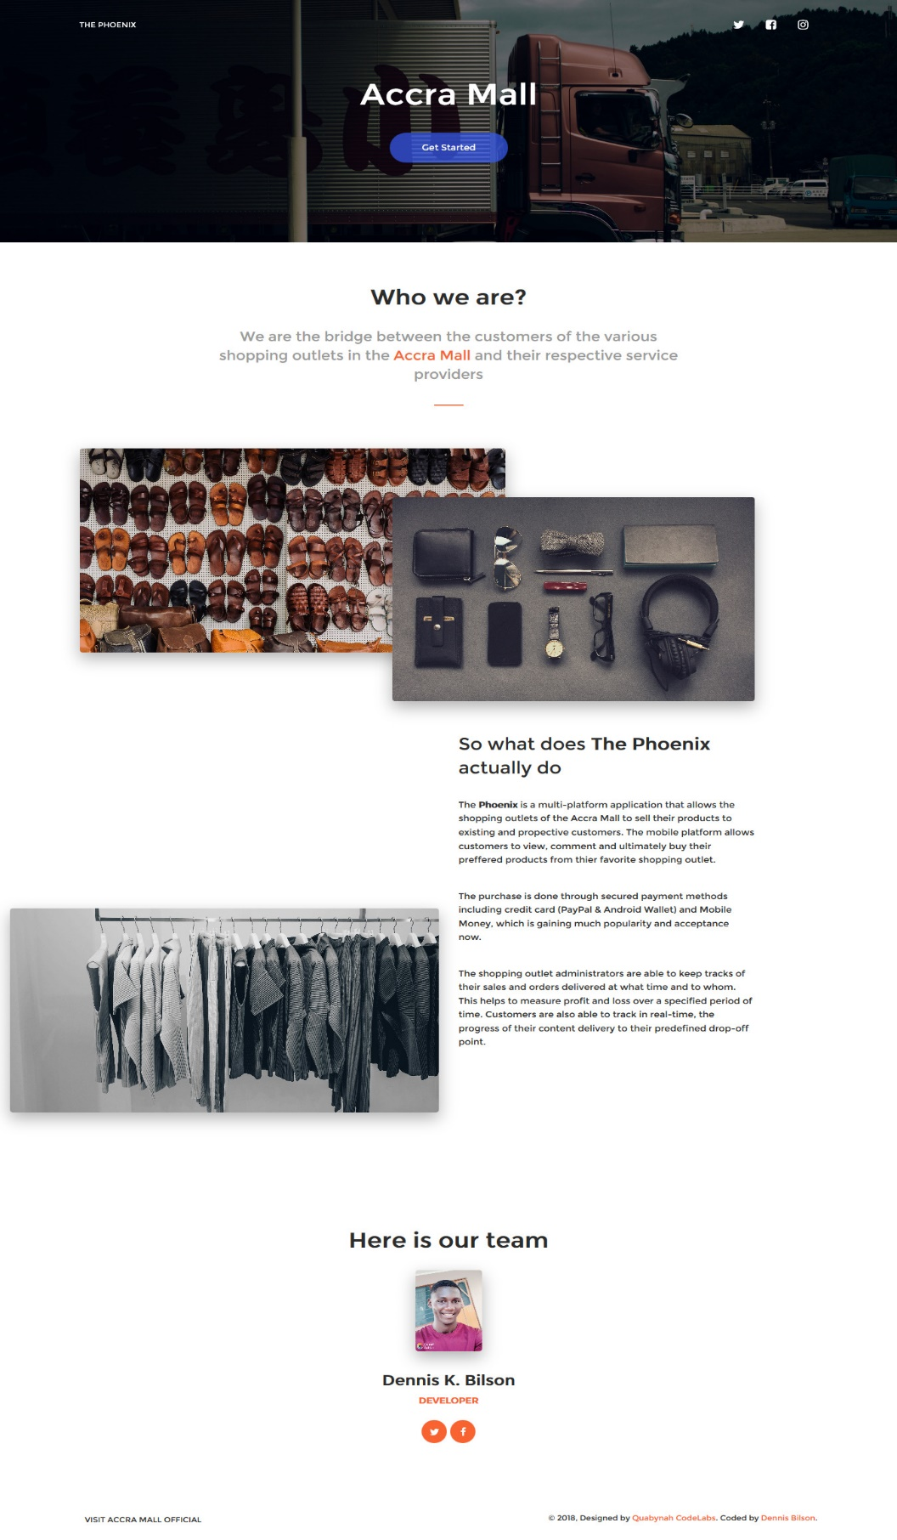

**STAFF ACCOUNT REGISTRATION PAGE**



**SHOP REGISTRATION PAGE**

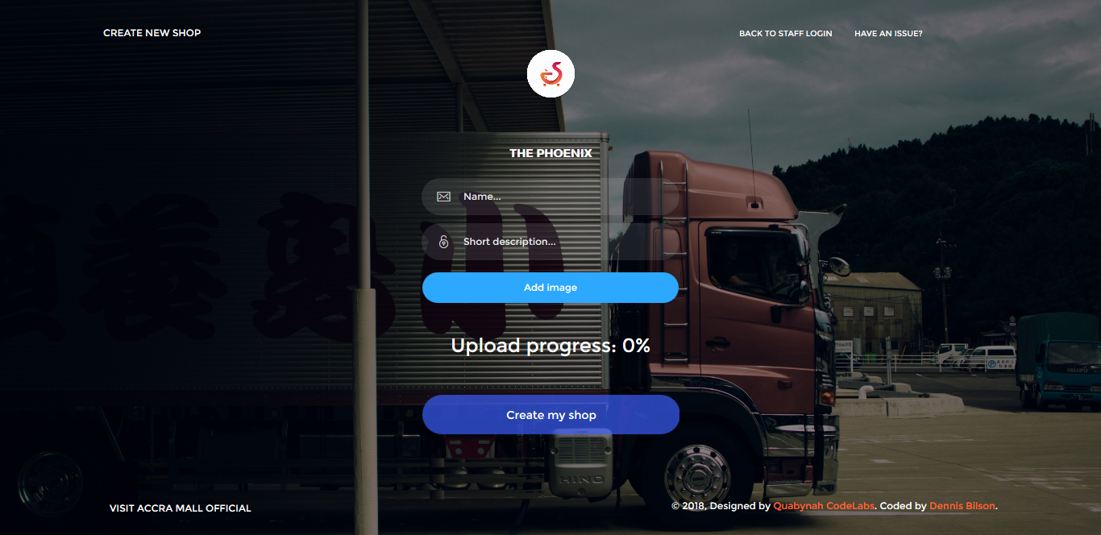

**STAFF LOGIN PAGE**

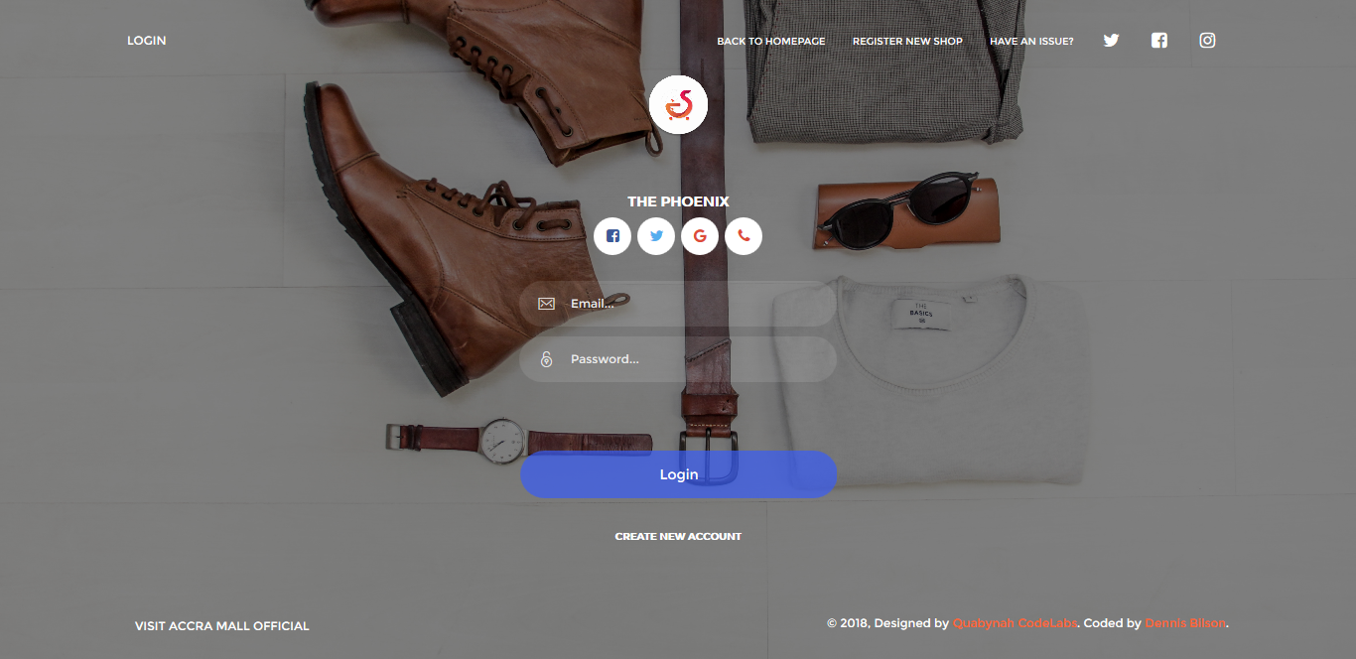

**DASHBOARD PAGE**

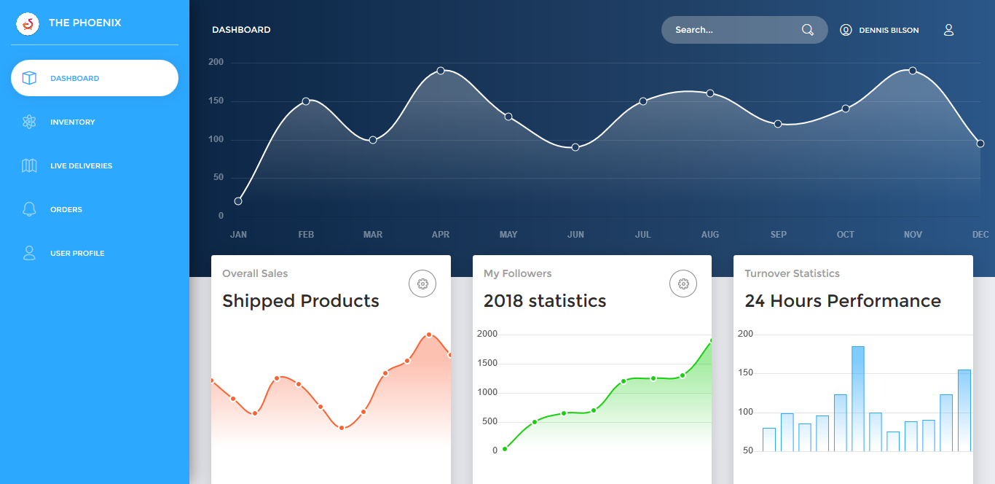

**INVENTORY PAGE**

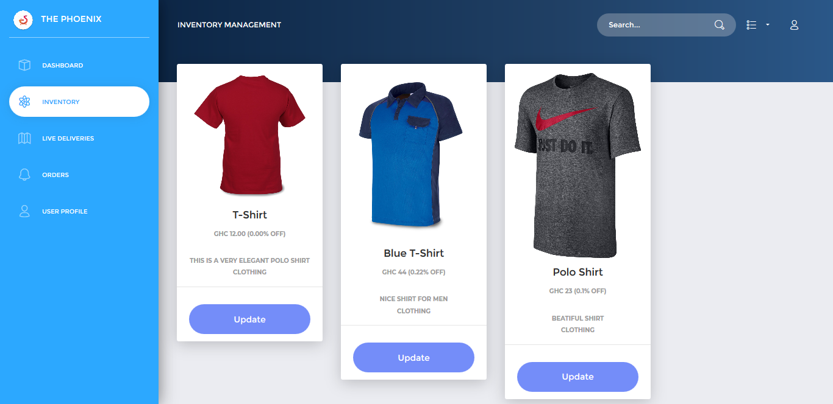

**PRODUCT DELIVERY TRACKING PAGE**

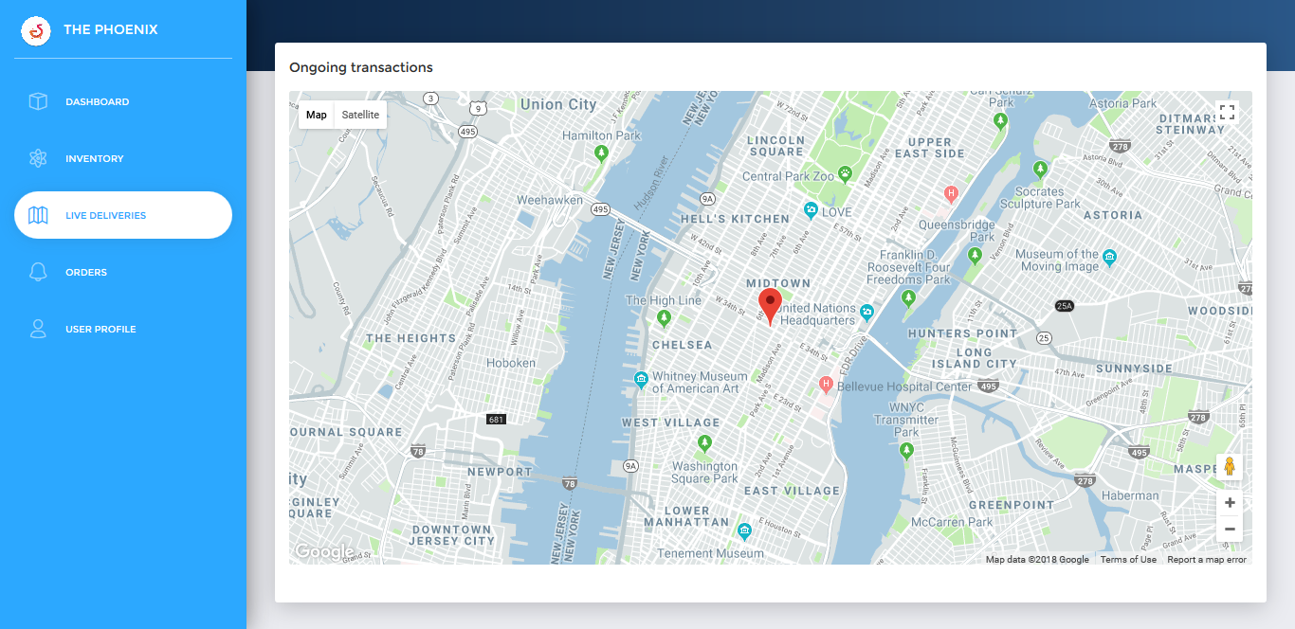

**PROFILE PAGE**

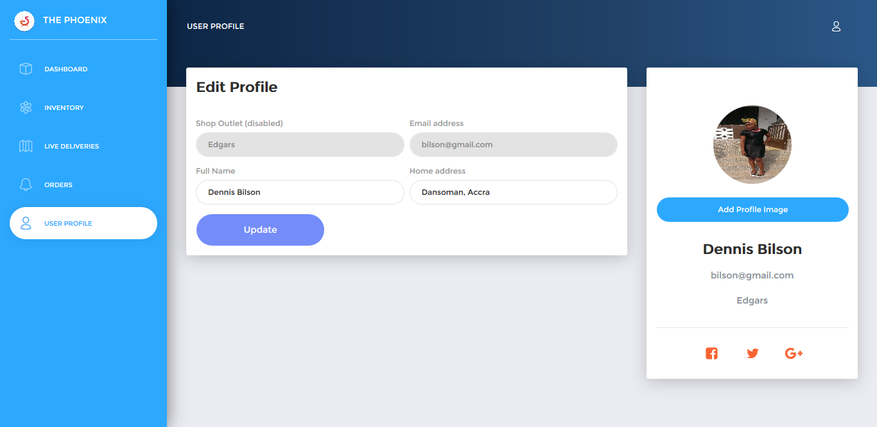

**APPENDIX B**

**APPENDIX C**

**APPENDIX D**

**APPENDIX E**

**ABOUT ACTIVITY**

**APPENDIX F**

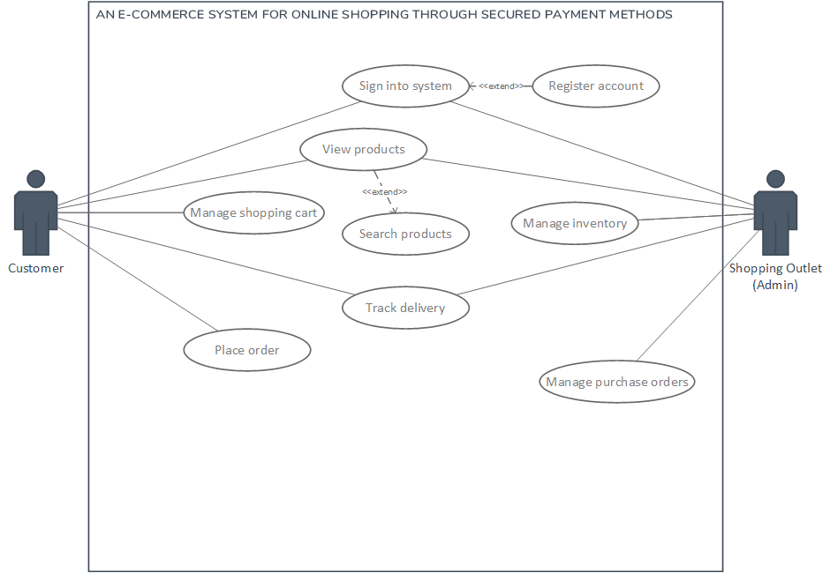**USE-CASE DIAGRAM**

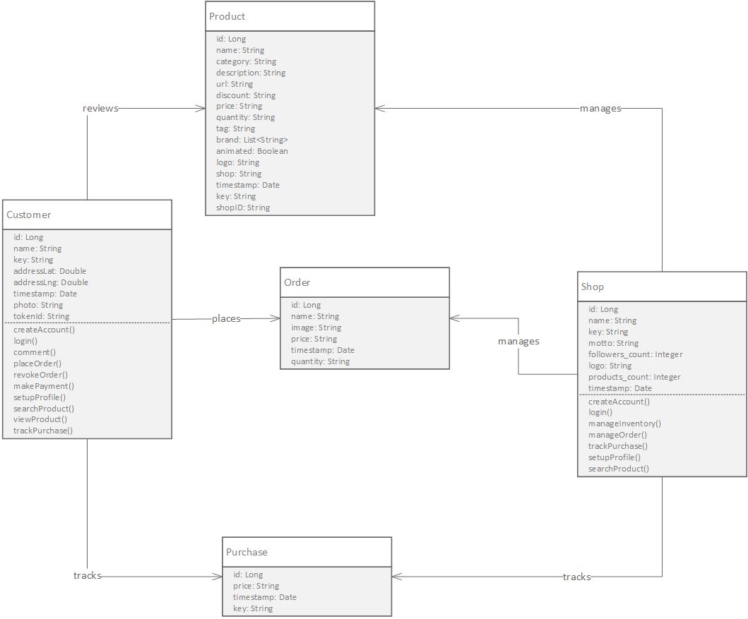**CLASS DIAGRAM**

**ACTIVITY DIAGRAM**